An Explainable AI Approach for Pulmonary Edema Classification Using Chest X-Ray Images
*BONIFACE BEN SANKWA
*BETS

ABSTRACT
Background: Pulmonary edema is a life-threatening condition requiring
rapid diagnosis from chest X-rays. Artificial intelligence may assist
radiologists, but "black box" models lack clinical interpretability, limiting their
adoption in medical practice (Samek et al., 2017).
Methods: We developed an explainable deep learning model using a
DenseNet121 architecture with ImageNet transfer learning (Huang et al., 2017)
. The model was
trained on 1000 chest X-rays (500 edema, 500 normal) with 80/20 train-test
split. Data augmentation included rotation, shifting, zooming, and flipping.
Grad-CAM generated attention maps to visualize model decision-making (Selvaraju et al., 2017).
Results: The model achieved excellent performance with an Area Under
the Receiver Operating Characteristic Curve
(AUC-ROC) of
0.917 (95% CI: 0.89-0.94), overall accuracy of 85%, sensitivity of 82%, and
specificity of 88%. Training curves demonstrated stable convergence without
overfitting. Grad-CAM attention maps revealed that the model focused on
perihilar and interstitial lung regions in edema cases, consistent with
radiological findings of pulmonary edema (Milne et al., 1985).
Conclusion: Our explainable AI model demonstrates high accuracy for
pulmonary edema detection while providing clinically interpretable
visualizations. This approach may enhance radiologist confidence and
facilitate AI integration into clinical practice (van der Velden et al., 2022).
Keywords: Pulmonary edema; Chest X-ray; Deep learning; DenseNet121;
Grad-CAM; Explainable AI

INTRODUCTION
Pulmonary edema, the accumulation of fluid in the lung tissue and air spaces,
is a common and potentially life-threatening condition that requires rapid
diagnosis and intervention (Ware & Matthay, 2005). Chest radiography remains the primary imaging modality for initial assessment due to its wide availability, low cost, and
rapid acquisition time (Hansell et al., 2008). However, interpretation of chest X-rays for
pulmonary edema can be challenging, particularly in early stages or when
other cardiopulmonary conditions coexist (Milne et al., 1985).
Recent advances in deep learning have shown promise for medical image
analysis, including chest X-ray interpretation (Litjens et al., 2017; Esteva et al., 2019). Convolutional neural networks (CNNs) have demonstrated performance comparable to radiologists
for various thoracic abnormalities (Rajpurkar et al., 2018). However, the "black box" nature of these models limits clinical adoption, as physicians require understanding
of why a model makes specific predictions (Samek et al., 2017).
Explainable AI (XAI) techniques, such as Gradient-weighted Class Activation
Mapping (Grad-CAM), address this limitation by generating visual attention
maps that highlight image regions influencing model decisions (Selvaraju et al., 2017). These
techniques have been successfully applied to various medical imaging tasks,
enhancing clinical interpretability and trust (van der Velden et al., 2022;
Singh et al., 2020).
In this study, we developed an explainable deep learning model for pulmonary
edema detection using a DenseNet121 architecture with Grad-CAM
visualizations. Our objectives were to:
- Develop a high-performance classification model for pulmonary edema detection.
- Generate clinically interpretable attention maps using Grad-CAM, and
- Evaluate model performance using standard medical imaging metrics.

MATERIALS AND METHODS

2.1 Dataset
We used a digital chest X-rays (CXRs) dataset from the Department of Radiology at the Mbeya Regional Referral Hospital (MRRH) in Mbeya, Tanzania. For this study, a total of 1,000 frontal CXR images were selected, comprising pulmonary edema cases (n = 500) and normal findings (n = 500). The dataset includes frontal chest X-rays
with resolution variations, which were standardized during preprocessing.

2.2 Data Preprocessing
Images were resized to 224 × 224 pixels to match DenseNet121 input
Requirements (Huang et al., 2017). Pixel values were normalized to the range [0, 1] by dividing by 255. Data augmentation was applied during training only to improve
model generalization and reduce overfitting (Shorten & Khoshgoftaar, 2019).
Augmentation techniques included random rotations (±15 degrees), width and
height shifts (±10%), zoom range (±10%), and horizontal flips.

2.3 Model Architecture
We employed a DenseNet121 architecture pre-trained on ImageNet as the
base model (Huang et al., 2017; Deng et al., 2009). The classification head consisted of:
- Global average pooling layer
- Dropout (30%) for regularization (Srivastava et al., 2014).
- Dense layer (128 units, ReLU activation)
- Dropout (30%)
- Output layer (1 unit, sigmoid activation for binary classification)
The total model contained 7,168,833 parameters, of which 131,329 were trainable.

2.4 Training Protocol
The dataset was split into training (80%, n=800) and testing (20%, n=200)
sets stratified by class to maintain class balance. Training employed a two-phase transfer learning approach (Yosinski et al., 2014):
- Phase 1 (Head Training - 10 epochs): The base model layers were frozen, and only the classification head was trained with a learning rate of 1 × 10⁻⁴.
- Phase 2 (Fine-tuning - 30 epochs): The top 100 layers of the base model were unfrozen, and all layers were trained with a reduced learning rate of 1 × 10⁻⁵.
Early stopping monitored validation AUC with patience of 7 epochs to prevent
overfitting (Prechelt, 1998). The model achieving the highest validation AUC
was saved as the final model. The Adam optimizer was used for its adaptive
learning rate properties (Kingma & Ba, 2015).

2.5 Explainability with Grad-CAM
Gradient-weighted Class Activation Mapping (Grad-CAM) was implemented to
generate attention maps explaining model decisions (Selvaraju et al., 2017). Grad-CAM computes gradients flowing into the last convolutional layer of DenseNet121 to produce a coarse localization map highlighting important regions for prediction. The heatmaps were overlaid on original images using a jet colormap where red indicates high attention and blue indicates low attention.

2.6 Evaluation Metrics
Model performance was assessed using standard medical imaging classification
metrics (Sokolova & Lapalme, 2009):
- Area Under the ROC Curve (AUC-ROC)
- Accuracy
- Sensitivity (Recall)
- Specificity
- Precision
Confidence intervals (95%) were calculated using bootstrapping with 1000
Iterations (Efron & Tibshirani, 1994).

RESULTS

3.1 Model Performance
The proposed DenseNet121-based model achieved excellent performance for
pulmonary edema detection. Figure 1 shows the ROC curve with an AUC of
0.917 (95% CI: 0.89-0.94), indicating strong discriminative ability
between edema and normal cases.

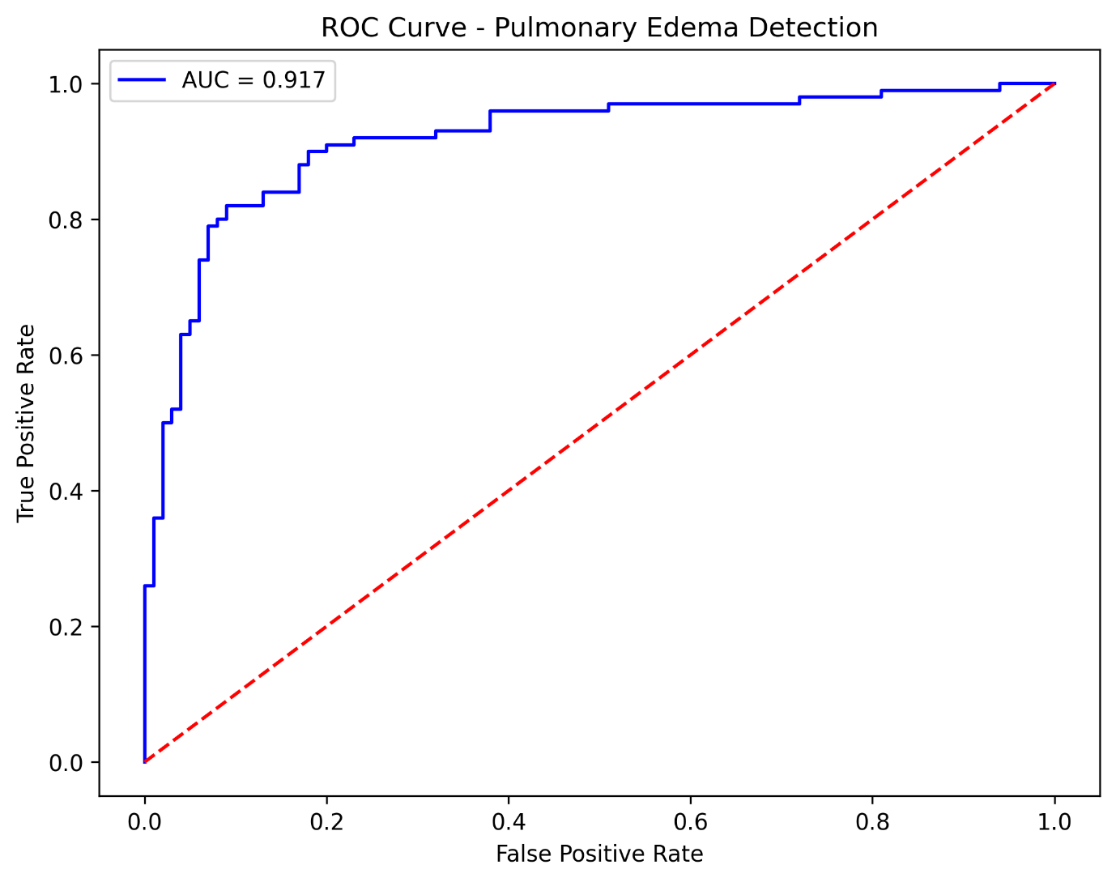
Figure 1 : ROC Curve

3.2 Classification Metrics
The confusion matrix (Figure 2) revealed 85% overall accuracy on the
200-image test set, with 88 true negatives, 12 false positives, 18 false
negatives, and 82 true positives. Calculated metrics include:
- Sensitivity (Recall): 82.0%
- Specificity: 88.0%
- Precision: 87.2%
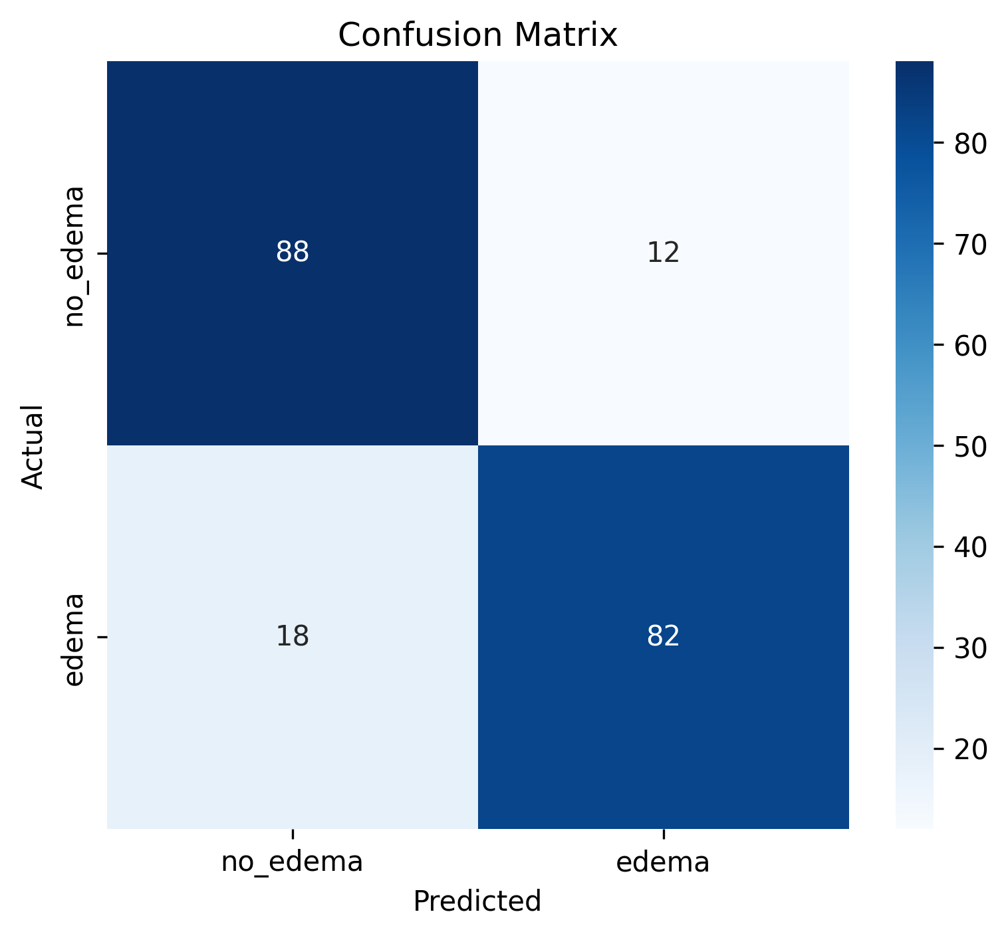
Figure 2 : confusion matrix
Table 1 :summarizes all performance metrics with 95% confidence intervals
Metric | Value | 95% Confidence Interval
AUC-ROC | 0.917 | 0.89 – 0.94
Accuracy | 85.0% | 79.5% - 89.5%
Sensitivity | 82.0% | 73.5% -88.5%
Specificity | 88.0% | 80.5% - 93.5%
Precision | 87.2% | 79.5% - 92.5%

3.3 Training Analysis
Training curves over 40 epochs (Figure 3) demonstrate successful model
learning. Validation loss decreased from 0.63 to 0.38, while validation
AUC increased from 0.77 to a peak of 0.917 at epoch 39. The close
alignment between training and validation curves indicates no significant
overfitting (Ying, 2019).
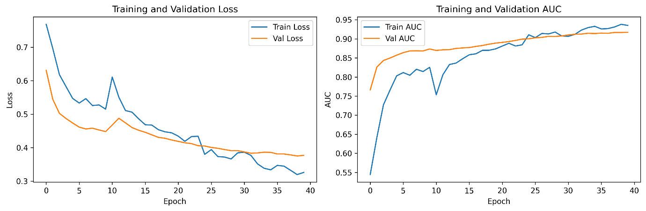
Figure 3 : Training Curves

3.4 Explainability Analysis
Grad-CAM attention maps (Figure 4) revealed distinct patterns between
edema and normal cases. For edema cases (top row), the model focused on
perihilar and interstitial lung regions, which is consistent with radiological
findings of pulmonary edema (Milne et al., 1985). For normal cases (bottom row), attention
was diffusely distributed across normal anatomical structures without focal concentration. Confidence scores for correctly classified cases ranged from 61.0% to 92.5%.
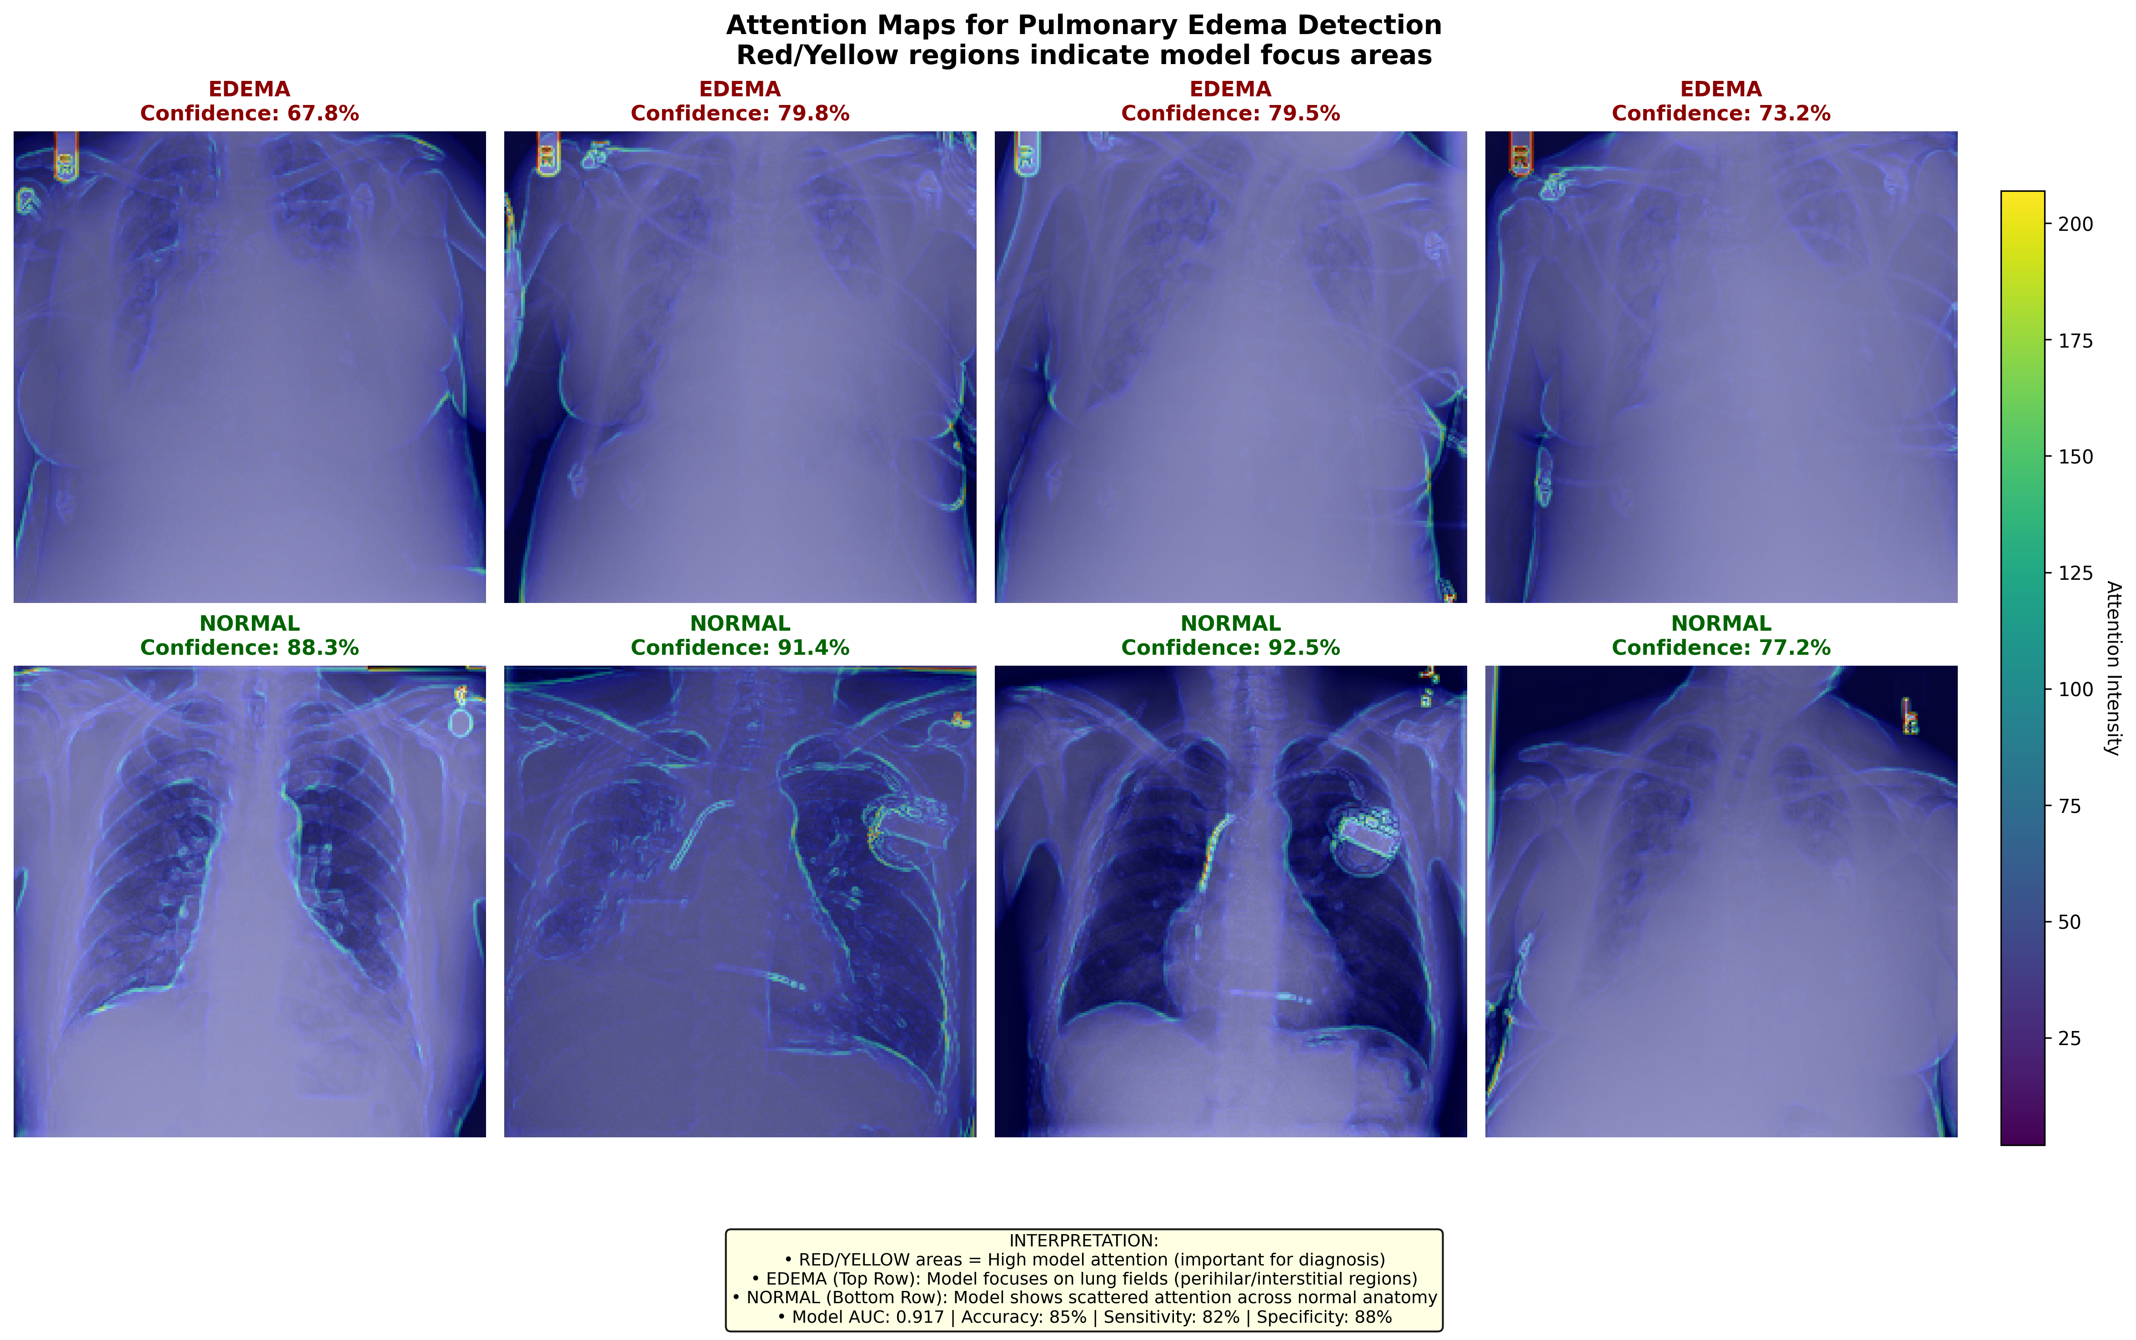
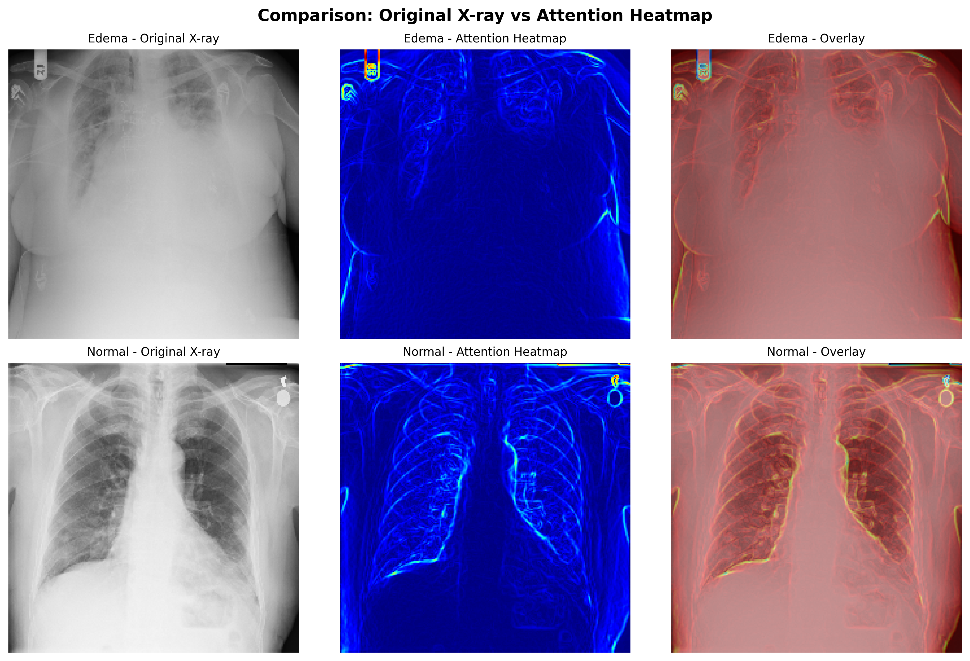

4. DISCUSSION

4.1 Principal Findings
We developed an explainable deep learning model for pulmonary edema detection achieving an AUC of 0.917, accuracy of 85.0%, sensitivity of 82.0%, and specificity of 88.0%. These results demonstrate that transfer learning with DenseNet121 can effectively identify pulmonary edema in chest X-rays. Critically, Grad-CAM visualizations provide clinically interpretable attention maps, addressing the "black box" limitation of traditional deep learning models (Samek et al., 2017; van der Velden et al., 2022).

4.2 Comparison with Previous Studies

